**Revised Technical Proposal**

**For**

**LOT – 5: Upgradation of NCDB Software**

**Customer Software Requirement Specification (SRS):**

1. Hold data of incidents, Accused information, Groups, Explosives, firearms, Vehicles, Addresses, Passports, CNICs, Media Files (documents, images, videos) etc.
2. Front end designed in .NET Framework & Database of MS SQL 2008
3. Accessible in both Versions (Desktop and Web Portal)
4. 25 data Entry form with Add, Edit, Delete options
5. Quick Search, Advance Search, Prospect, Chart Manager, Support for i-2 Analyst notebook, Dynamic Reports, Database Backup and User Rights & Permissions are main features
6. Integration and support provision to application with i-2 Analyst Notebook, Chart Manager and provide search facility using the work and pdf documents.
7. Recreation of replica of front end by fixing bugs and including new forms and reports for RED book.

**Proposed Work To Do:**

1. **Hold data of incidents, Accused information, Groups, Explosives, firearms, Vehicles, Addresses, Passports, CNICs, Media Files (documents, images, videos) etc**.

Current Entry Form:

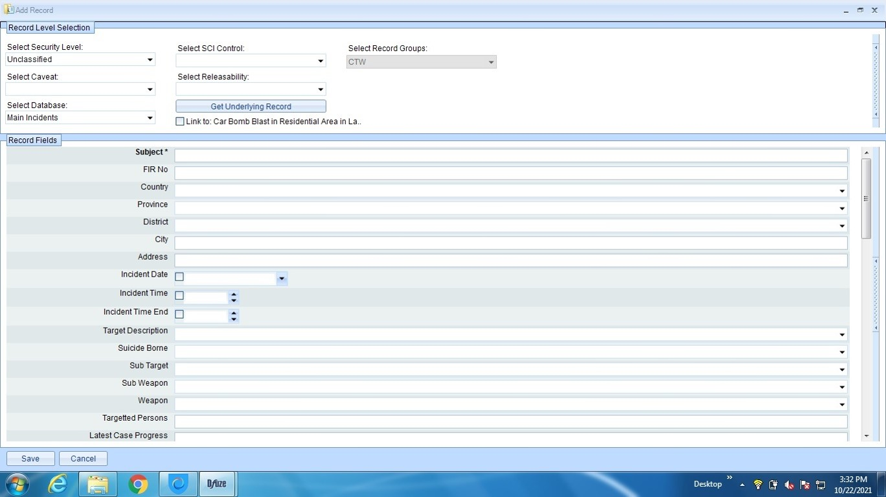

**Proposed Solution:**

* Complete Entry Form will be designed and develop with better UI/UX (User Interface/User Design).
* We will manage to develop user-friendly interface.
* Minimum data to be enter with maximum output.
* Maintaining the standard rules of Human Computer Interaction (HCI).
* The entry form will be divided in different steps as per easy usage requirement to avoid data destruction due to any reason.
* Mandatory data entry checks will be implemented.

1. **Front end designed in .NET Framework & Database of MS SQL 2008.**

As the database is already is MS SQL 2008.we will develop the front-end design in latest version of C-Sharp(C#) using .Net Framework

1. **Accessible in both Versions (Desktop and Web Portal)**

The application will be developed and design as per end user requirement. The front-end will be developed responsive for all platforms i.e desktop, web and with limited Mobile accessibility for remote data entry only.

1. **25 data Entry form with Add, Edit, Delete options**

All the data entry forms will develop as per user-requirement having crud operation i.e (Create, Update/Edit, Delete).

1. **Quick Search, Advance Search, Prospect, Chart Manager, Support for i-2 Analyst notebook, Dynamic Reports, Database Backup and User Rights & Permissions are main features**
2. **Quick Search:**

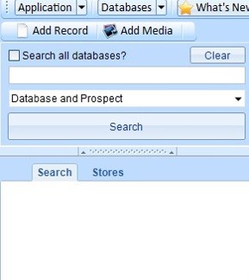

**Current Search Engine:**

**Proposed Solution:**

* The same search engine will be develop for user as per requirement.
* All fields relevant for searching will be displayed having most features and easy user interface will deployed.
* Real run time generic reporting feature will be deployed here.

1. **Advance Search:**

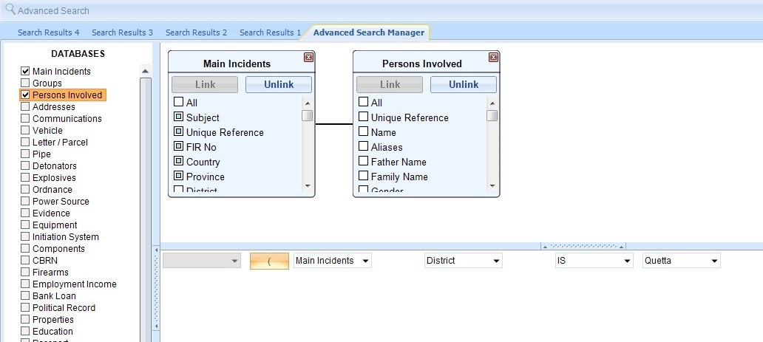

**Proposed Solution:**

* The advance search engine will be develop for user as per requirement.
* All fields relevant for searching will be displayed having most features and easy user interface will deployed.
* Real run time generic reporting feature will be deployed here.
* Real time searching/fetching data retrieval quires from all fields of database will be developed as per user requirements.

1. **Prospect:**

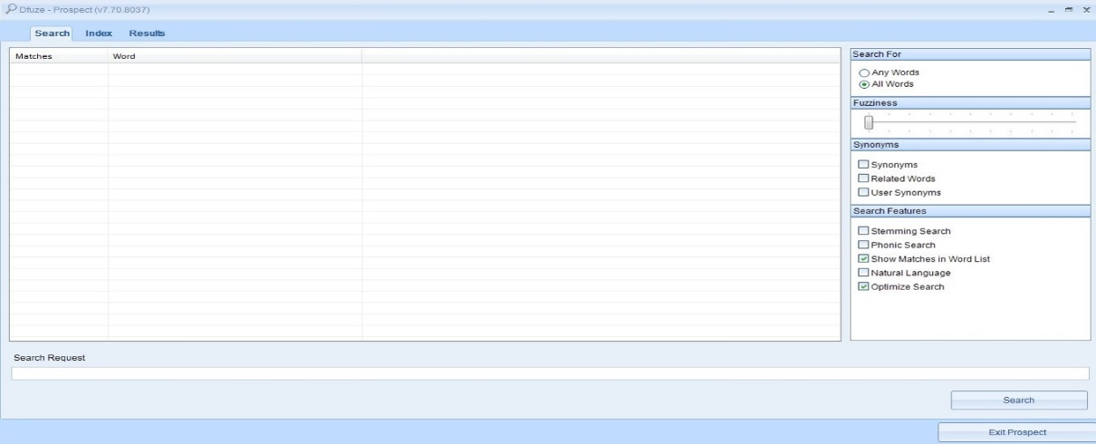

* The same feature form will be developed.
* Any updation suggested by user will be deployed.
* Indexing will be added for quick search and database normalization.

1. **Chart Manager:**

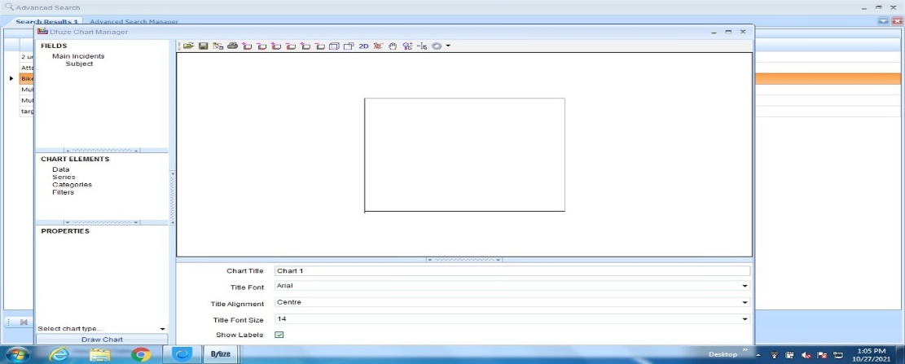

**Proposed Solution**:

* The same feature form will be developed as chart manager.
* Any updation suggested by user will be deployed.

1. **Support for i-2 Analyst notebook:**

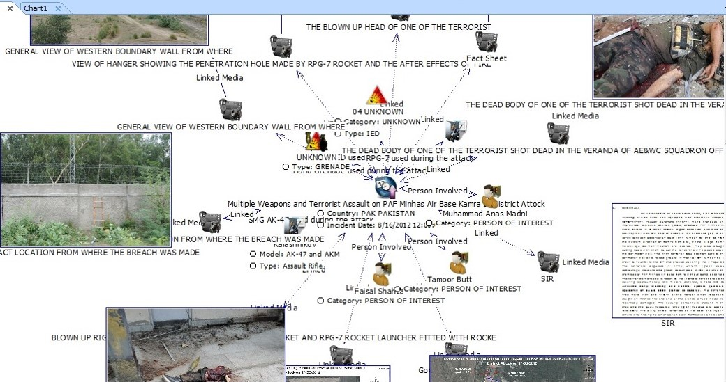

**Proposed Solution**:

* The API for integration with i-2 analyst notebook will be used for the current features.
* The same reporting technique will also be integrated in this current system for the ease of user.

1. **Dynamic Reports, Database Backup and User Rights & Permissions:**

**Proposed Solution**:

* As mentioned above the reports will be design and developed dynamically as per user requirement.
* Database backup modular feature will be created as well as different strategies for auto data backup will be implemented by time and data strings.
* User rights and permissions module will develop as per organization bylaws and user requirement having latest modular features.

1. **Integration and support provision to application with i-2 Analyst Notebook, Chart Manager and provide search facility using the work and pdf documents.**



**Proposed Solution**:

* The API for integration with i-2 analyst notebook will be used for the current features.
* The same reporting technique will also be integrated in this current system for the ease of user.

1. **Recreation of replica of front end by fixing bugs and including new forms and reports for RED book.**

* Improve the front end of current existing system by removing the bugs and include the new forms and reports as per client requirement for Red book as discussed.